Weighing Indicator

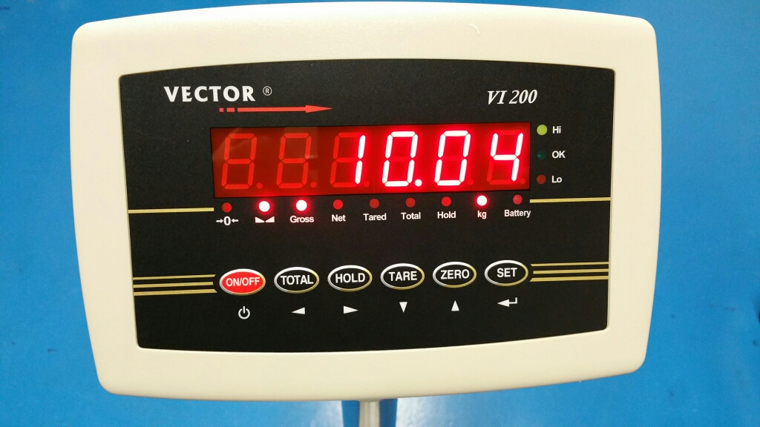

User manual

 safety instruction

For safety operation pls. follow the safety instruction.

 WARNING
set. Calibrate, inspect and fix the the weighing indicator is prohibited by Non professional staff

WARNING
Pls. make sure the weighing display well earthing

 | WARNING
 | The indicator is electrostatic sensitive device, pls. power off during electrical connections, internal components touched by hand is prohibited, and please take the anti-static measure

LIST
1. Summary 3
1.1 Main function 3
1.2 Technical parameter 3
1.3 Outline and installation picture 4
1.4 Battery 5
2. Installation and Calibration 5
2.1 connection indicator with load cell 5
2.2 communication interface 6
3. Basic operation 6
3.1 Key and display 6
3.2 Power on 10
3.3 Zero setting 10
3.4 TARE 10
3.5 HOLD 10
3.6 TOTAL 11
3.7 10 times high resolutions 12
3.8 Up and Low limit alarm 12
3.9 Print function 13
4 Calibration & parameter setting 13
4.1 Enter calibration 13
4.2. Step of calibration operation: 14
4.3 Application parameter setting 16
4.4 Communication setting 17
4.5 Application setting 18
4.6 Exit setting 20
5.Output data format 20
5.1 Computer continuous sending format 20
5.2 Big display continuous sending format 21
5.3 Serial interface reception command： 22
5.4 Print output format 23
5.5 Print the accumulated output format 23
6. Maintenance 24
6.1 Regular Error and maintain method 24
6.2 Daily maintenance 25
6.3 Restore default parameters 26

1. Summary

1.1 Main function
》General weighing: zero tare
》Animal weighing: Peak-hold. Data-hold, Auto-hold
》Accumulation
》Optional by RS232
》Low battery remind
》Power off automatically

1.2 Technical parameter
》Stimulating voltage：+3.3 VDC
》A/D converting speed： 10 SPS
》Load signal range: 0~12.8mV
》load capacity： it can connect 4 pcs 350Ω load cell at most
》weight unit： kg.
》Resolution： 3000e
》Interval： 1/2/5/10/20/50
》Display： 6-digits LED/LCD，word height: 20.3mm
》key： ON/OFF TOTAL HOLD TARE ZERO SET
》Interface：RS232C Baud rate optional 1200/2400/4800/9600
》Operation temperature： -10～40℃
》Storage temperature： -20～+60℃
》optional power： 4V/4Ah rechargeable battery
110/220VAC

1.3 Outline and installation picture

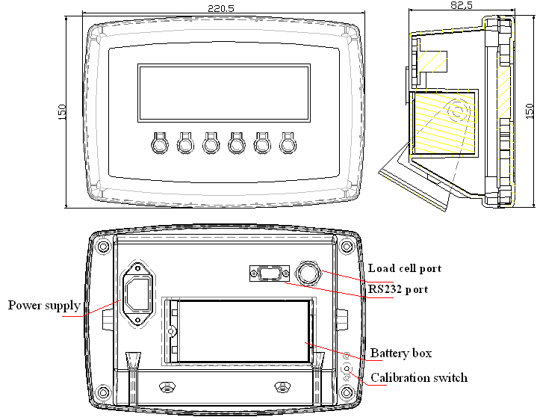

1.4 Battery
1. when you use the internal battery first time，you should charge the battery 10-12 hours, to prevent low voltage resulted from self leakage of battery.
2. when the red battery light is on and flashes，it means low battery You should charge battery in time.
3. Charge time: 10-12 hours And it works 45 hours
4. When the battery light turns green, it means fully charged
5. If you don’t use the battery long time, take out the battery to protect the indicator from battery leakage
6. In order to keep the battery in best using condition, it is suggest that you fully discharge the battery every month, the method is that using the indicator till it is automatically power off.

2. Installation and Calibration

2.1 connection indicator with load cell

it can connect four pcs 350Ωload cell at most, both four and six line load cell are ok. To make it simple, we use quick connector
Or standard plug. As belows

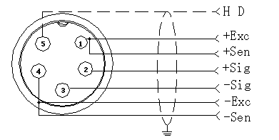

Quick connector connection

2.2 communication interface

PIN2-------TXD
5 4 3 2 1 PIN3------RXD
PIN5 --------GND
9 8 7 6

3. Basic operation
3.1 Key and display

Weighing indicator display instruction
LED display | instruction
 | Weighing data display
Kg | Weight unit kg
HOLD | Hold the data
Tare | Display tare status
Net | Display net weight
Gross | Display gross weight
 | Display data keep still
 | zero, indicating zero weight
Battery | Using battery
Hi | Over Limit
OK | Within Limit
Lo | Below Limit
Total | Accumulation
Count | Counting function

Key’s function
ON/OFF, EXIT AND SAVE SETTING
LEFT
RIGHT
DOWN
UP
CONFIRM, GO TO NEXT STEP

Key symbol | Key name | Key function
 | SET | Work together with “on/off” enter and exit calibration
 | ZERO | Clear weight within zero range
 | TARE | 1.At Gross mode, tare the loaded weight  2.At Net mode, display gross weight after deduct tare
 | HOLD | Enter and exit “hold” mold
 | TOTAL | accumulating operation
 | ON/OFF | Press it for 2 seconds to power on or power off

3.2 Power on
Power on and indicator perform self-checking and go to weighing mode.

3.3 Zero setting
Within zero range, press “zero”, indicator weighing is cleared. When
Indicator is not stable, zero is unworkable.

3.4 TARE

At the gross weight mode, if the weight is stable, pls. press ”Tare” key , the indicator will take the loaded weight as tare, and show net weight,
At this time the gross mode will change to net mode. The “ net” and “tare” light is on, and the net weight is zero

3.5 HOLD
C11=0 “hold” function unworkable

C11=1 PEAK HOLD
Press” HOLD” key, the Hold light is on, and show the Maximum data on the weighing indicator. Press “ HOLD” key again to exit the hold function

C11=2 Data-hold
Press” HOLD” key, the Hold light is on, and show the data on the weighing indicator. Press “ HOLD” key again to exit the hold function

C11=3 Auto-hold
If the weight on the scales above 20d and keep stable, the indicator will show the data for 6 seconds and the “ hold” light Is on , after 6 seconds the indicator back to general weighing, and the “ hold” light is off

C11=4 Special Animal weighing function
Press” Hold” key, the indicator will show” LOC” for 3 seconds, the “ hold” light is on, During the 3 seconds, the indicator will catch the average weight and show it.
Press” HOLD” key again to exit it

3.6 TOTAL
Accumulation operation
At Zero mode, load weight till stable, Press “TOTAL” key go to accumulating
Mode,” total” light on, display” n001”, and then display loaded weight; unload weight , back to zero, load weight again till stable. Press ”TOTAL”, display”n002”
Then show the loaded weight. Repeat it maximum 999 times.
Check the total weight operation:
Press “SET” hold it then press “TOTAL” At the same time, display ”n**”, (accumulating times) then display total weight.

There are 8 data totally. It shows the first 4 digital. then the last 4 digital
For example, the first 4 digital is”0012”, the last 4 digital is”34,56”
It means the actual weight is “1234.56”

At TOTAL (accumulate) mode, Press “TOTAL” key the indicator show“ clrn”, it means don’t clear the total Weight, Press “ key confirm it and exit ; if clear total weight, Press “” “”
“clrn” change to “clry” it means clear total weight display. Press “”to clear the the total weight and exit accumulating mode.

3.7 10 times high resolutions
Press “ SET” and “TARE” key at the same time, you will get 10 times high resolutions. And it back to normal weighing after 3 seconds.

3.8 Up and Low limit alarm
Pls. set C13= Up limit, C14=Low Limit, when the weight is over up limit, the “HI” light will on, and indicator will make a sound to alarm.; when the weight is below than the low limit, the “LO” light will on.. when the weight is within the limit, the “OK” light is ok.

3.9 Print function
When the data is stable, connection with printer, it will be printed after press“ ”1 second.

Note：print the gross weight when at tare mode , if the net weight is zero. Can not print.

4 Calibration & parameter setting

4.1 Enter calibration
There have two methods to enter the setting menu:
1. when the switch” CAL” is off, Press” ” then press” at the same time, hold it, you will enter C08-C39 setting.
2. Take out the sealing screw on the back of indicator, then press
down the “span” Press still and then press at the same time , you will enter C01-C39 setting.

4.2. Step of calibration operation:
According to the second method which can enter setting menu, C01-C39

C01 UNIT
[C01 ] Press
[C1 1] unit is kg
Press , go to next step
C02 Set decimal digits
[C02 ] Press
option：0/1/2/3/4
[C2 0] no decimal point
[C2 1] one decimal point
[C2 2] two decimal point
[C2 3] three decimal point
Press , go to next step
C03 Division setting
[C03 ] Press
[C3 1] d=1
[C3 2] d=2
[C3 5] d=5
[C3 10] d=10
[C3 20] d=20
[C3 50] d=50
Press , go to next step
C04 Maximum capacity
For example:max weighing 100kg:
set [0100.00]
Press , go to next step
C05 Zero calibration
option：0=non-calibration zero 1=need calibration zero
calibration zero please choose 1 and ensure scale is empty and “stable” light is on. countdown[CAL 10]~[CAL 0], then the indicator will show[0.00](example for two decimal point).
C06 Loading calibration
[C06], Press , show [C06 0], press , change to [C06 1], Press , show [SPAn ],
Basic on max capacity setting, add suitable weight on scale. close to the max capacity, heavier than 10% max at least.
For example: the weight is 80kg
As bellows:
[0080.00]
[CAL 9]
……
[0080.00]
[CALEnd]
count down over, indicator shows loaded weight , loading calibration finish.
If you want to set application parameter. Press If you want to exit. Press
C07 Default parameters setting
[C07 0] non-restore default parameters
[C07 1] restore default parameters
Note: after the above parameters setting finish, please do not set default parameters often, avoid the original setting parameters lost.

4.3 Application parameter setting
C08 warning tone
[C8 1] open warning tone
[C8 0] close warning tone
C09 Power off automatically
[C9 0] Non-power off
[C9 10] keep still within 10 min. power off automatically
[C9 30] keep still within 30 min. power off automatically
[C9 60] keep still within 60 min. power off automatically
C10 Power saving setting
[C10 0] close backlight
[C10 1] close backlight after 1 minute
[C10 2] always backlight
C11 Hold
[C11 0] No Hold function
[C11 1] Peck hold
[C11 2] Data hold
[C11 3] Auto-hold
[C11 4] Animal weighing
C12 Hold time ( if you choose C11=4, you can set the time )
[C12 3] 3 seconds
[C12 5] 5 seconds
C13 Upper limit alarm value
C14 Low limit alarm value
C15 Check inner code

4.4 Communication setting
C18 Serial interface setting
[C18 0] No sending
[C18 1] Big display
[C18 2] Print format output
[C18 3] Command mode(Z =zero T=tare R=Reply weight
[C18 4] continuous sending
C19 BAUD RATE
[C19 0] 1200bit/s
[C19 1] 2400bit/s
[C19 2] 4800bit/s
[C19 3] 9600bit/s

4.5 Application setting
C20 Manually Zero
[C20 00] no Manually Zero
[C20 01] Manually Zero range ±1% Max. capacity
[C20 02] Manually Zero range ±2% Max. capacity
[C20 04] Manually Zero range ±4% Max. capacity
[C20 10] Manually Zero range ±10% Max. capacity
[C20 20] Manually Zero range ±20% Max. capacity
[C20100] Manually Zero range ±100% Max. capacity
C21 Initially zero
[C21 0] No initially zero
[C21 1] Initially zero range±1% Max. capacity
[C21 2] Initially zero range±2% Max. capacity
[C21 5] Initially zero range±5% Max. capacity
[C21 10] Initially zero range±10% Max. capacity
[C21 20] Initially zero range±20% Max. capacity
C22 Zero tracking range
[C22 0.0] No zero tracking
[C22 0.5] ±0.5d
[C22 1.0] ±1.0d
[C22 2.0] ±2.0d
[C22 3.0] ±3.0d
[C22 4.0] ±4.0d
[C22 5.0] ±5.0d
C23 Zero tracking time
[C23 0] No zero tracking
[C23 1] 1 second
[C23 2] 2 seconds
[C23 3] 3 seconds
C24 Overload range
[C24 09] Over 9d than max. capacity
C25 Negative display
[C25 00] Less than -9d
[C25 10] Less -10% Max. capacity
[C25 20] Less -20% Max. capacity
[C25 50] Less -50% Max. capacity
[C25100] Less -100% Max. capacity
C26 Standstill time
[C26 0] Quick
[C26 1] Medium
[C26 2] Slow
C27 Standstill range
[C27 1] ±1d
[C27 2] ±2d
[C27 5] ±5d
[C27 10] ±10d
C28 Dynamic filter
[C28 0] close dynamic filter
[C28 1] Low dynamic filter
[C28 3] Medium dynamic filter
[C28 5] High dynamic filter
C29 Noisy filter
[C29 0] Close noisy filter
[C29 1] Low noisy filter
[C29 2] Medium filter
[C29 3] High filter

4.6 Exit setting
For example [C10 1], Press , confirm it then press to exit and save it

5.Output data format

5.1Computer continuous sending format
 |  | , |  |  | , |  |  |  |  |  |  |  |  |  |  | CR | LF

S 1 S 2 S 3 Data S 4

S1: weight status, ST= standstill, US= not standstill, OL= overload
S2: weight mode, GS=gross mode, NT=net mode
S3: weight of positive and negative, “+” or ” –“
S4: measurement unit, “kg” or “lb”
Data: weight value, including decimal point
CR: carriage return
LF: line feed

5.2 Big display continuous sending format
Output continuous format
S  T  X | S  W  A | S  W  B | S  W  C | X | X | X | X | X | X | X | X | X | X | X | X | C  R | C  K  S
1 | 2 |  |  | 3 |  |  |  |  |  | 4 |  |  |  |  |  | 5 | 6

State A
Bits0,1,2
0 | 1 |  | 2 | Decimal point position
1 | 0 |  | 0 | XXXXXX0
0 | 1 |  | 0 | XXXXXXX
1 | 1 |  | 0 | XXXXX．X
0 | 0 |  | 1 | XXXX．XX
1 | 0 |  | 1 | XXX．XXX
Bits3,4 |  |  |  | Division
0 |  | 1 |  | X1
1 |  | 0 |  | X2

State B
BitsS | function
Bits0 | gross=0， net=1
Bits1 | symbol：positive =0，negative =1
Bits2 | overload（or lower zero）=1
Bits3 | dynamic=1
Bits4 | unit：lb=0, kg=1
Bits5 | Constant 1
Bits6 | Constant 0

State C
Bit2 | Bit1 | Bit0 | unit
0 | 0 | 0 | Kg or lb
0 | 0 | 1 | g
0 | 1 | 0 | t
Bit 3 |  |  | printing=1
Bit 4 |  |  | Extend display=1
Bit 5 |  |  | Constant 1
Bit 6 |  |  | Constant 0

5.3 Serial interface reception command：
RS232COM serial interface can receive simple ASCII command.
Command word and role as follows:
Command | name | role
T | Tare off command | Save and clear tare
Z | Zero command | Zero the gross weight
P | Print command | Print the weight
R | Read gross/ net weight | Read gross/net weight

5.4Print output format
NO. 004 （NO.）
G.W: 8.88kg (gross，example for two decimal point)
T.W: 2.88kg （tare）
N.W: 6.00kg （net）

5.5 Print the accumulated output format
NO. 004 （NO.）
Total: 003 (accumulate times，example for 3 times is 003)
Total.W: 2.88kg （accumulate weight）

6. Maintenance

6.1 Regular Error and maintain method
Error | Reason instruction | Solution
Display UUUUUU | 1. the loaded weight excess overload range of max. capacity  2. wrong connection with load cell or no connection with it.  3. load cell unworkable | 1.decrease loaded weight  2. check load cell connection  3. checking load cell：check input and output resistance to judge it is good or not.
Display nnnnnn | 1. calibration is no good  2、cell single line is connect a wrong line.  3、the cell is bad. | 1. check scale is resisted or not, foot is kept level or not.  2. check load cell connection.  3. checking load cell：check input and output resistance to judge it is good or not.
ERR1 | during calibration, no input added weight or input weight exceed max capacity. | Input the correct weight
ERR2 | during calibration, the added weights not enough | Added weight at least 10%of Max. capacity, Recommend the weights is 60-80% the Max. capacity
ERR3 | during calibration, input single is negative. | 1..Check connection is correct or not.  Check load cell is damaged or not.  3. renew calibration, if still wrong. pls replace the PCB
ERR4 | During calibration, single is unstable | Ensure added weight and scale is stable, start calibration
ERR5 | EEPROM check error | change PCB.

6.2 Daily maintenance
1. In order to ensure indicator display clearly and prolong use life, the indicator should not be placed directly on sunlight.
2. Load cell and indicator should be well connected , the system should have a good ground, away from strong electric field, magnetic field.
3. Do not use indicator outside in rainy, better keep it power off.
4. Power off firstly while plug and unplug

6.3 Restore default parameters
Enter setting menu, set C07= 1,press then press exit saving setting, all parameters will be back to default setting.
Note：Pls. do not restore default parameter easily if you are not professional and have not scale calibration.

Default parameter form
parameter | instruction | Default value
C01 | Calibration unit | 1
C02 | decimal digits | 0
C03 | Division value | 1
C04 | Max capacity | 10000
C05 | Empty scales calibration | 0
C06 | Capacity calibration | 0
C07 | restore the default parameters | 0
C08 | Warning tone | 1
C09 | Automatic power off | 0
C10 | Power saving mode | 0
C11 | Hold function | 0
C12 | Animal weighing mode | 0
C13 | Upper limit warning | 000000
C14 | Lower limit warning | 000000
C15 | Inner code display
C16 | Date
C17 | Time
C18 | Serial interface data output methord | 0
C19 | Serial interface Baud rate | 3=9600
C20 | Manual zero setting | 2
C21 | Initical zero setting | 10
C22 | Automatic zero tracking range | 0.5
C23 | Automatic zero tracking time | 1
C24 | Verload range | 9
C25 | Negative display range | 10
C26 | Standstill time | 1
C27 | Standstill range | 2
C28 | Dynamic filter | 0
C29 | Noisy filter | 2
C30~C40 | Reseverd menu

